Cloud Sync LES Writeback Bug Bash

What is Cloud Sync LES Writeback?
Cloud Sync LES Writeback gives customers a way to sync certain attributes from Exchange Online down to Active Directory. Importantly, only dir-synced users are in scope in this scenario, so effectively these users have object-level SOA in AD, but attribute-level SOA (for certain Exchange attributes) in Exchange Online/Entra. In other words, an LES Transfer has been performed for these users.
For more information, see the design here: LES Writeback Design Spec.docx

Prerequisites
In Active Directory:
- Ensure your Active Directory schema is extended for Exchange Server.
  - To verify that this has been done:
    - Active Directory Users and Computers > Right click on a user > Properties > Go to the Attribute Editor tab
      - If you don’t see this tab, make sure Advanced Features is selected under View
    - Look for the attribute msExchMailboxGuid – if this exists, your schema has been extended for Exchange Server
  - To extend your AD schema for Exchange Server:
    - Install Exchange Server image (iso file) on your DC:
      - Exchange Server 2019 (recommended)
      - Exchange Server 2016
    - Right click on the Exchange ISO image file and select Mount. Note the assigned drive letter
    - Open an elevated Command Prompt, navigate to the above drive, and run the following cmdlet: Setup.exe /IAcceptExchangeServerLicenseTerms_DiagnosticDataON /PrepareSchema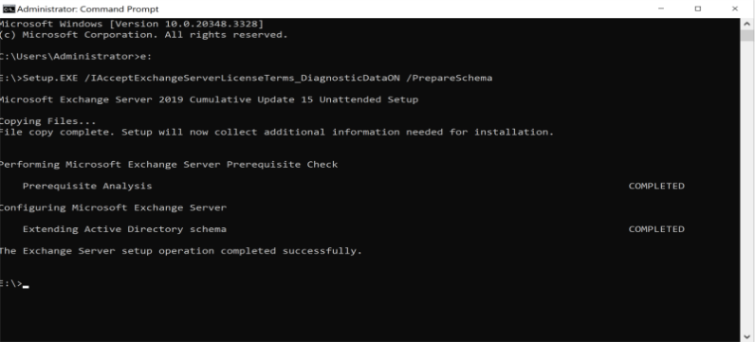
    - Restart your provisioning agent so that it can pick up the schema changes:
      - 1. Press Win + R, type “services.msc,” and hit Enter
      - Look for something like “Microsoft Azure AD Connect Provisioning Agent,” right-click and choose Restart
In Entra ID:
- If you need a tenant with Exchange licenses, claim an admin user from the table below to log into the shared bug bash tenant. The tenant domain name for login is @M365x47469755.onmicrosoft.com:
Username | Password | Claimed by
admin1 | Xaza770123 | Minh
admin2 | Doka179035 | Umair
admin3 | Xatu582196 | Aditi
admin4 | Qaro528456
admin5 | Qubo351072 | Adam
admin6 | Taqo971022 | Ming
admin7 | Karu030507 | Mukesh’s team

- Use your admin user to set up this compatible version of the Provisioning Agent from the develop branch: [link to v1.0.2192.0 installer] the released agent here should work
  - Agent install instructions: Install the Microsoft Entra provisioning agent - Microsoft Entra ID | Microsoft Learn (steps 7-17 under Install the agent)
  - Create an AD to Entra ID Cloud Sync configuration in the Portal between your AD DC and Entra ID: Microsoft Entra Cloud Sync new agent configuration - Microsoft Entra ID | Microsoft Learn
- Or (alternative to 2) use the claimed admin user when setting up Connect Sync
- Ensure that the sync job is active and healthy
- Ensure you have an on-prem user that is being synced up to Entra ID – we will refer to this user as user A from here
- Create a running LES Writeback job for your AD domain
  - First, create an instance of the LES Writeback app (AKA a service principal) in the tenant that you will use with your AD domain. Call the MSGraph API as documented here, using “3b99513e-0cee-4291-aea8-84356239fb82” as the application template ID and using your AD domain name as the display name
  - Then, create a job in your service principal as documented here, using “Entra2ADExchangeOnlineAttributeWriteback” as the template ID
  - Save your AD domain name into the service principal’s secrets as documented hSere
  - Finally, start the job as documented here
Bug Reporting
To report any bugs found, please add child items to: Product Backlog Item 3423629 Cloud Sync LES Writeback - Bug Bash Tracker

Test Scenarios

Scenario 1: Exchange attributes are written back on prem for Exchange cloud-managed users

Objective
Verify that if an on-prem user with Exchange attributes managed in the cloud has a relevant attribute changed in the cloud, the change is synchronized down to AD.

Steps
- Find your synced test user – user A – in the M365 admin center here and assign either the M365 E5 license or the Microsoft Teams Enterprise license to them (use the three dot menu)
- Open PowerShell and connect to Exchange Online (EXO) using the cmdlet: Connect-ExchangeOnline. Make sure the EXO module is installed and imported.
  - To install: Install-Module -Name ExchangeOnlineManagement -Scope CurrentUser -Force –AllowClobber
  - To import: Import-Module ExchangeOnlineManagement
  - If you get an error when trying to install related to minimum version of NuGet, close the current PowerShell window, open a new one, and run: Install-PackageProvider -Name NuGet -MinimumVersion <min version> -Force, then repeat steps a and b
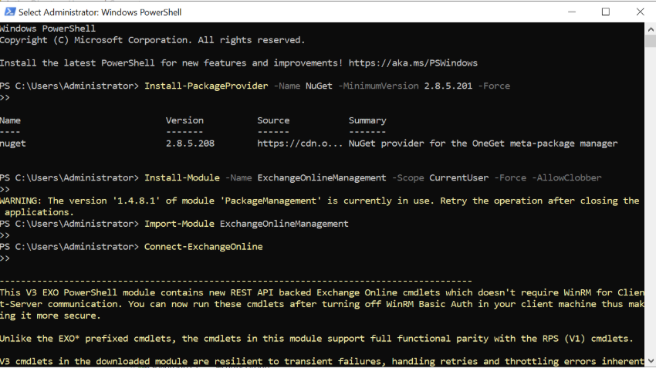
- Run the cmdlet: Get-Mailbox -ResultSize Unlimited. Verify that you see the alias of user A here
- Set the SOA of Exchange attributes to the cloud by running the cmdlet: Set-Mailbox -Identity <alias> -IsExchangeCloudManaged $true, where <alias> is the alias of user A from the previous cmdlet
- Modify the value of an Exchange Online attribute in Entra ID by running the same cmdlet as such: Set-Mailbox -Identity <alias> -CustomAttribute1 “<testValue>”
  - Note that the attributes are named slightly differently in the cmdlet parameters vs. in the job schema

Expected Outcomes
- The attribute value is synced to the user in AD
- Provisioning and audit logs display appropriate information about the sync operation
Tester | Result / Bug Link
Ming | Sync Succeeded but see Microsoft.Online.Workflows.SourceOfAuthorityViolationException in audit log.
Adam | Sync succeeded for custom attributes but saw a failure, Microsoft.Online.Workflows.SourceOfAuthorityViolationException, in the audit log for other attributes.
Umair | Sync Succeeded after provision on demand
Minh | Succeed after the provision on demand (I provisioned another attribute, CustomAttribute2).

NOTE: It is known that users moving into scope for the job for the first time do not get provisioned to AD during delta sync cycles (only initial sync cycles). Provisioning On Demand is necessary to move these objects into scope during delta sync. See a sample POD API call here for reference.

Scenario 2: Attribute changes are skipped when the user goes out of scope

Objective
Verify that changes to Exchange attributes are not synced to AD if Exchange attribute SOA is switched to on-prem in the same sync cycle.

Steps
- Using the cmdlets in the previous scenario, modify the value for a cloud-managed Exchange attribute for your test user
- Immediately toggle the user’s Exchange cloud-managed status to false

Expected Outcomes
- The attribute value is not synced to the user in AD
- Provisioning and audit logs display appropriate information about the skip operation
Tester | Result / Bug Link
Ming | Success
Adam | Success
Umair | Success
Minh | Success

Scenario 3: Changes sync when user moves back in scope

Objective
Verify that Exchange attribute changes sync for users when they move back in scope for the job.

Steps
- Building on the setup from the previous scenario, toggle the user’s Exchange cloud-managed status back to true
- Modify the value of an Exchange attribute for the user and verify that the change syncs down to AD during the next sync cycle

Expected Outcomes
- The change is synchronized to AD and the provisioning and audit logs contain entries indicating as much
Tester | Result / Bug Link
Ming | success
Adam | Sync was successful but I turned Cloud SOA Off/On twice and didn’t see a log for the second On call. UPDATE: Log showed up later. It had the right timestamp.
Umair | success
Minh | Success with a call out – it seems like if the attributes used in Scenario 2 and 3 are different, both attributes will be synced in Scenario 3, without needing a POD. This is different from LES Transfer

NOTE: It is known that users moving into scope for the job for the first time do not get provisioned to AD during delta sync cycles (only initial sync cycles). Provisioning On Demand is necessary to move these objects into scope during delta sync.

Scenario 4: Transferring object SOA to cloud moves users out of scope

Objective
Verify that flipping source of authority to the cloud for a synced user moves the user out of scope for LES Writeback.

Steps
- Call the MSGraph API as documented here to transfer object-level SOA for your test user into the cloud
- Modify an Exchange attribute for the test user and verify that the change doesn’t sync to AD

Expected Outcomes
- The change is skipped because the user is out of scope, and the provisioning and audit logs contain information indicating as much
Tester | Result / Bug Link
Umair | Success and seeing correct audit log (skipped since SOA switched to cloud). Also see "Microsoft.Online.Workflows.SourceOfAuthorityViolationException
Minh | Success. ImportSkipped audit event name with AzureDirectoryServiceCloudManagedObject error code. No provisioning logs.  However, I did not see this success until the second attempt. I flipped the SOA in MS Graph, then changed the Exchange attribute. I saw audit logs saying the attribute was changed, but nothing after that. It wasn't only I changed a second Exchange attribute did I see the ImportSkipped audit event
Adam | Success. I see no sync to AD and see ImportSkipped logs. Worth mentioning that the ImportSkipped Audit log doesn’t show what object is skipped.
Ming | Success, see correct audit log(skipped since source of authority of this object switched from AD to cloud only. Only objects sourced from AD can be synced), but also see "Microsoft.Online.Workflows.SourceOfAuthorityViolationException audit log. However, I don’t see provisioning log.

